Journal Peer Review Workflow System
Fact-Finding Form & Report
Systems Analysis | Planning & Analysis Phase

1. Twenty Questions and Answers

1.1 Open-Ended Questions (10)
# | Question | Answer
1 | How does the current peer review process work from submission to decision? | Authors email manuscripts to the editorial office. The managing editor logs each one in a spreadsheet, checks formatting, and forwards it to the editor-in-chief. The editor assigns reviewers by email, collects reports, and sends a decision letter manually.
2 | What are the biggest problems you face in the current process? | Lost emails, delays in reviewer replies, no central tracking of manuscript status, duplicated data entry, and difficulty finding past review history.
3 | How do you currently select reviewers? | Editors choose from personal contacts and a static list of past reviewers. There is no record of expertise, workload, or past performance, so the same reviewers are overused.
4 | How do authors find out the status of their paper? | They email the editorial office and wait for a manual reply, which can take several days.
5 | What information should the system show on each manuscript? | Title, authors, abstract, keywords, version history, assigned reviewers, review deadlines, current status, reviewer comments, and the final decision.
6 | How do you handle conflicts of interest and confidentiality? | Editors check manually and rely on reviewer honesty. Anonymity is kept by removing names from files by hand, which is error-prone.
7 | What reports do you need from the system? | Number of submissions per period, average review time, acceptance/rejection rate, reviewer workload, and overdue reviews.
8 | What would make the system easier for reviewers? | One login, a clear list of assigned papers, deadline reminders, a structured review form, and the ability to accept or decline an invitation with one click.
9 | How should the system notify users? | Automatic emails and in-system notifications for new assignments, approaching deadlines, submitted reviews, and decisions.
10 | What do you expect from the new system in the next few years? | Scalability for more submissions, integration with plagiarism-checking and indexing services, and full digital archiving of every decision.

1.2 Closed-Ended Questions (10)
# | Question | Options | Answer
11 | Is the current process fully manual? | Yes / No | Yes, mostly manual
12 | Do authors receive automatic confirmation after submitting? | Yes / No | No
13 | Is there a central database of reviewers? | Yes / No | No (only a spreadsheet)
14 | How many reviewers are usually assigned per manuscript? | 1 / 2 / 3 / 4+ | 2 to 3
15 | Is the review double-blind? | Yes / No | Yes
16 | Are reviewers reminded automatically about deadlines? | Yes / No | No
17 | Can the editor view all manuscript statuses in one place? | Yes / No | No
18 | Should authors be able to upload revised versions online? | Yes / No | Yes
19 | Does the system need role-based access (Author, Reviewer, Editor, Admin)? | Yes / No | Yes
20 | Is a final decision letter generated automatically today? | Yes / No | No

2. Interview Questions (10)
Interviewee: Managing Editor of the journal
Interviewer: Systems Analyst

# | Question | Interviewee Response
1 | Can you describe your role and daily tasks in the review process? | I receive submissions, check them, assign reviewers, and follow up until a decision is sent.
2 | How many manuscripts do you handle per month? | Around 40 to 60, and it keeps growing.
3 | What part of the process takes the most time? | Waiting for reviewers and chasing them by email.
4 | How do you keep track of manuscript status? | Through a spreadsheet and my email inbox.
5 | Have you ever lost or mixed up a manuscript or review? | Yes, a few times, usually because of email attachments.
6 | How do you ensure reviewers stay anonymous? | I manually remove names from the files before sending.
7 | What do authors complain about most? | Slow responses and not knowing the status of their paper.
8 | What features would help you most in a new system? | A dashboard, automatic reminders, and automatic decision letters.
9 | Are you worried about moving to a new system? | A little. I worry about training and moving old records.
10 | What would make you consider the new system a success? | Shorter review time, no lost files, and happier authors and reviewers.

3. Web Form Questions (10)
Target respondents: Authors, Reviewers, and Editors.
Format: Google Form (screenshots of the form, questions 1 to 10).

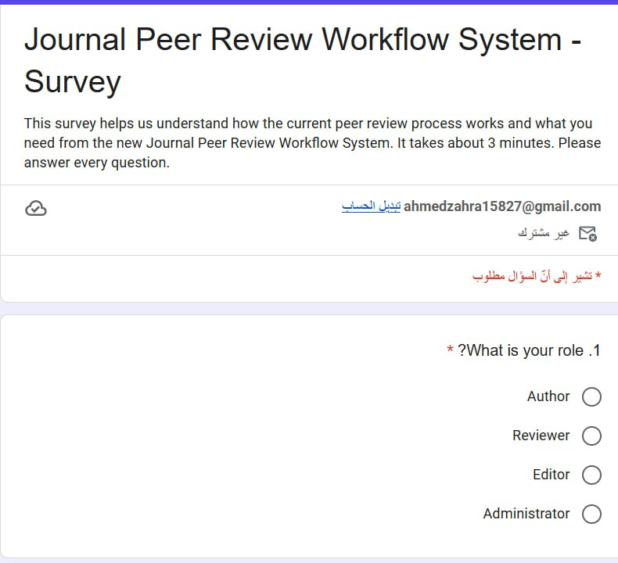
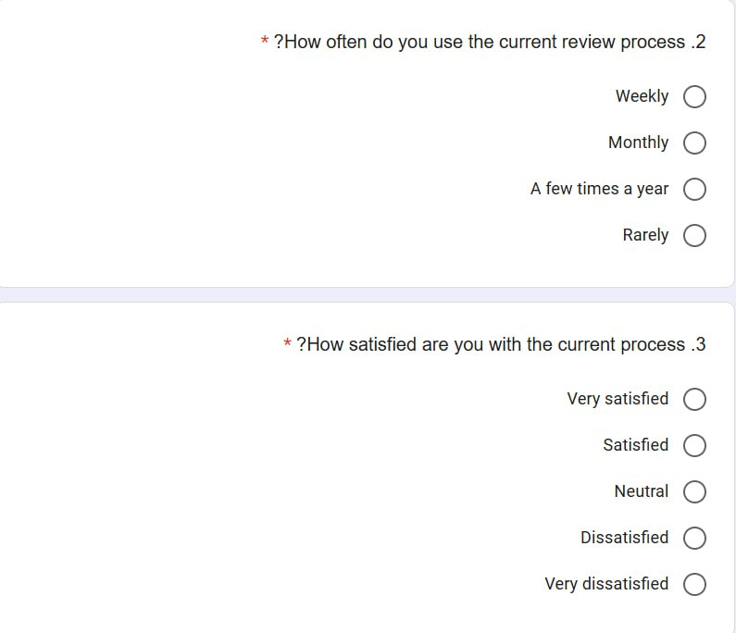
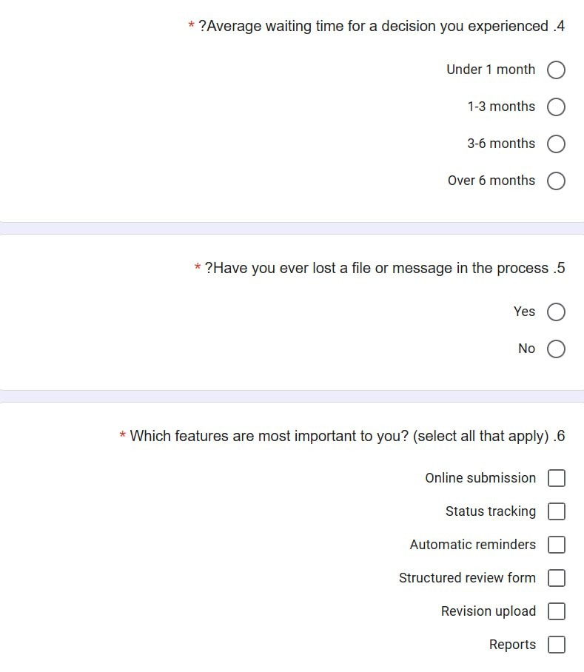
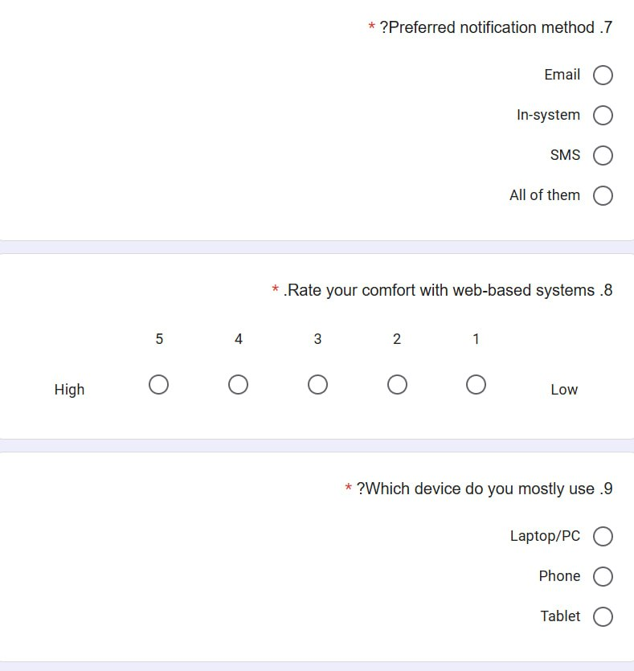
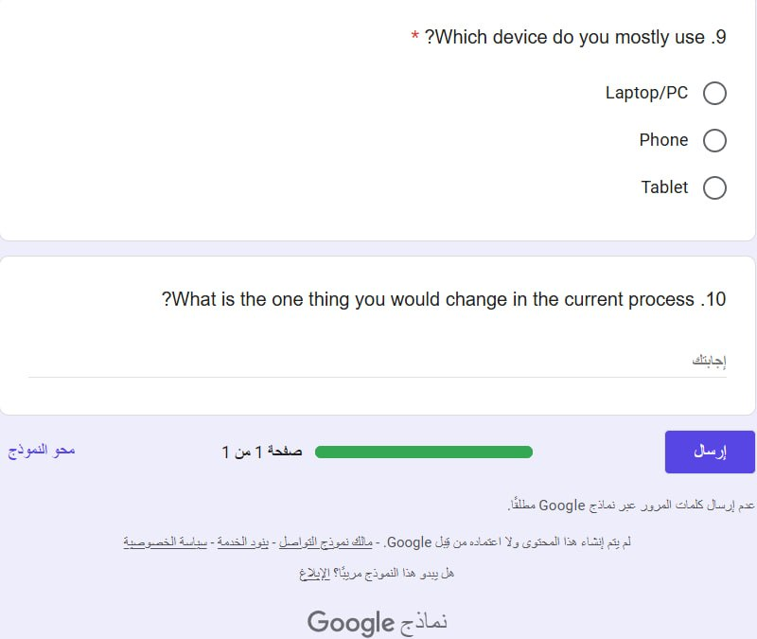

4. Report

4.1 Interview Opinion
The managing editor believes the current process is workable but inefficient. Their opinion is that the biggest weakness is the dependence on email and spreadsheets, which makes tracking slow and unreliable. They support a web-based system with a dashboard, automatic reminders, automatic decision letters, and a structured review form. They also believe manual anonymization is risky and should be automated.

4.2 Interview Feelings
The interviewee was frustrated about time spent chasing reviewers and answering status emails, and embarrassed by past lost files. They were cooperative and open during the interview. They showed cautious optimism about the new system, with mild concern about staff training and migrating existing records. Their overall attitude was positive, provided the system is simple and well supported.

4.3 Current State of the System
- The process is mostly manual, built on email and a spreadsheet.
- There is no central database of manuscripts, authors, or reviewers.
- Reviewer selection depends on personal contacts, with no expertise or workload data.
- Status tracking is manual, and authors must ask by email.
- Deadline reminders, decision letters, and anonymization are done by hand.
- No automatic reports exist, and review history is hard to search.
- Result: long review times, lost files, duplicated work, and low user satisfaction.

4.4 System Goals
- Provide online manuscript submission with automatic confirmation.
- Store all manuscripts, reviews, and decisions in one central database.
- Support roles: Author, Reviewer, Editor, and Administrator.
- Let editors assign reviewers using expertise and workload information.
- Send automatic notifications and deadline reminders.
- Enforce double-blind anonymity and conflict-of-interest checks.
- Give authors real-time status tracking and online revision upload.
- Generate decision letters and management reports automatically.
- Reduce average review time and eliminate lost files.
- Keep the system secure, easy to use, and scalable for future growth.

